What does each codes do:
Data cleaning first code:
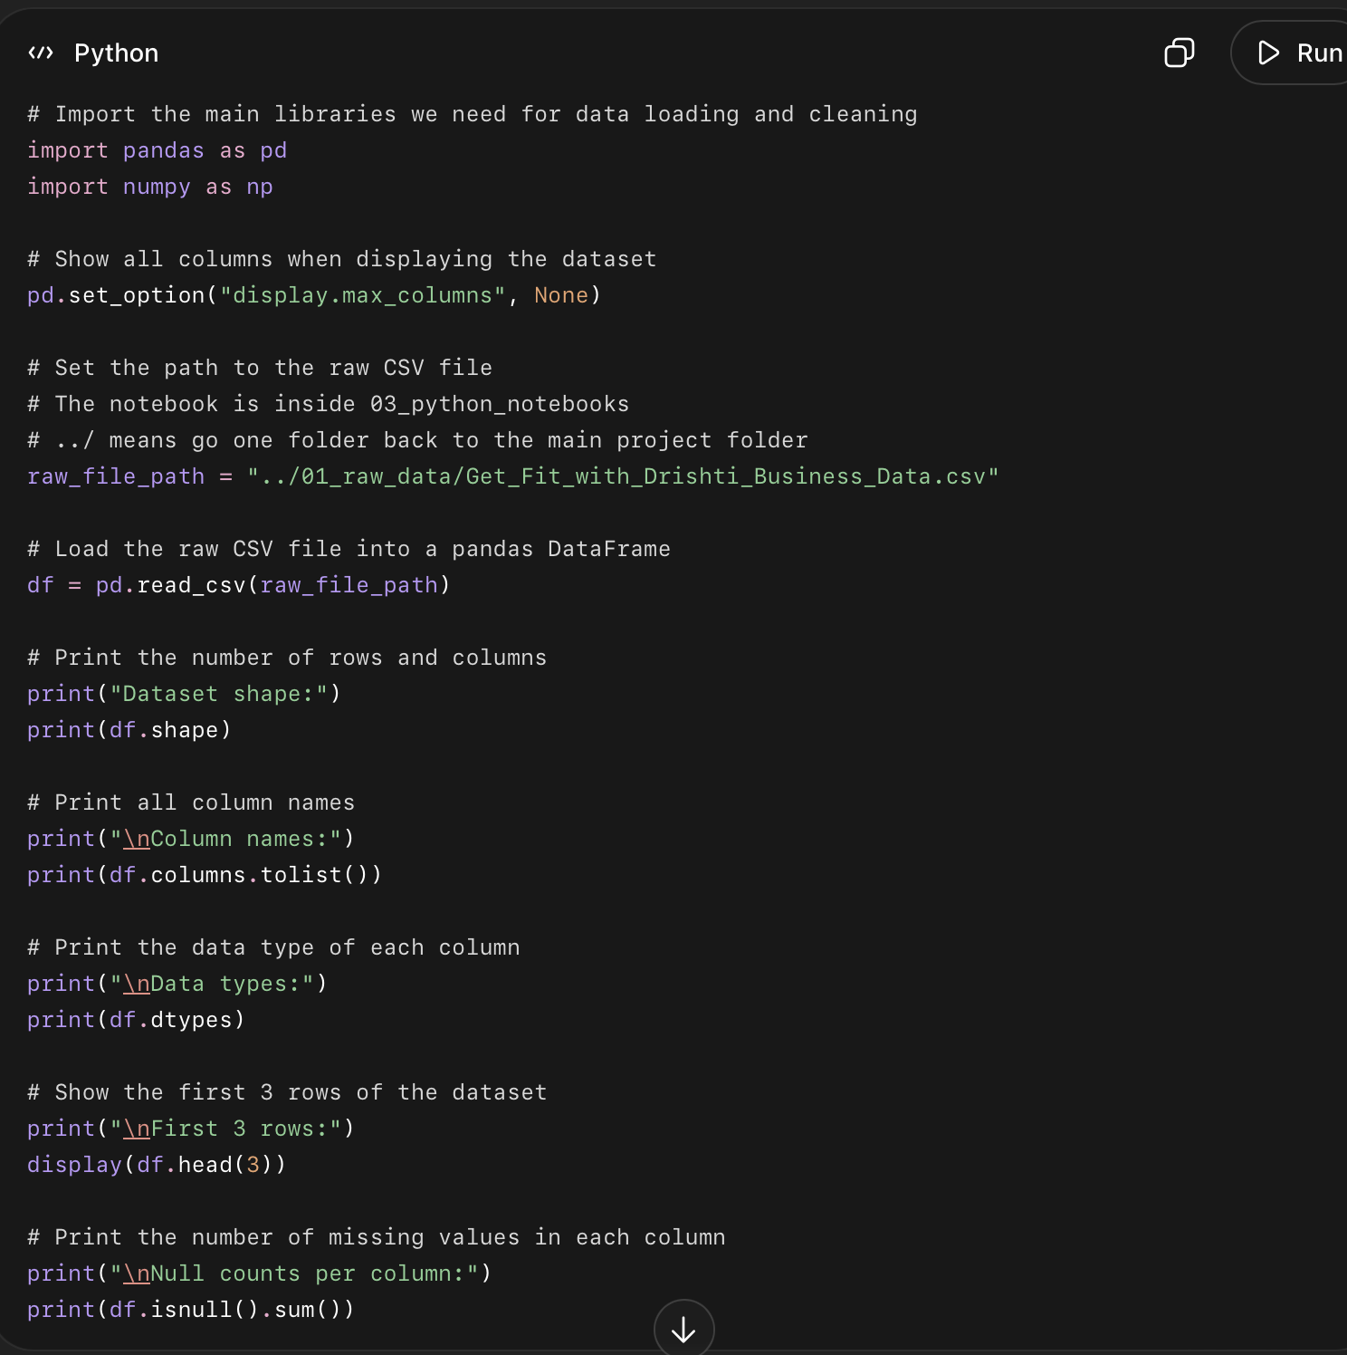

What the code did
- Imported pandas and numpy
  - These help Python work with data tables and numbers.
- Told Jupyter to show all columns
  - So we can see the full dataset instead of hidden columns.
- Found the CSV file
  - It used this path:
../01_raw_data/Get_Fit_with_Drishti_Business_Data.csv
- Loaded the CSV into Python
  - The data is now stored in a table called:
df
- Checked dataset size
  - Output:
(3000, 41)
- Meaning: 3,000 rows and 41 columns.
- Printed all column names
  - This confirms all expected columns are present.
- Checked data types
  - This shows which columns are text, numbers, or dates stored as text.
- Displayed first 3 rows
  - This lets us quickly see what the raw data looks like.
- Checked missing values
  - This shows how many null/blank values each column has.

Simple documentation text
I loaded the raw CSV file into Python using pandas and confirmed that the dataset contains 3,000 rows and 41 columns. I inspected the column names, data types, first three rows, and missing values to understand the original condition of the data before cleaning.

Second code
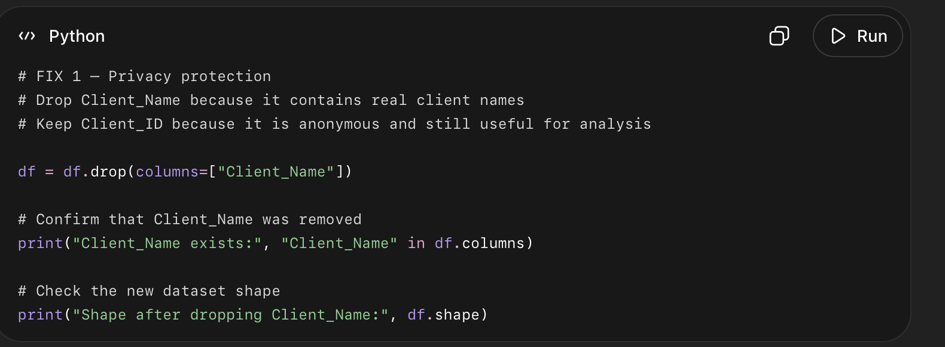

What this code did
- Removed the Client_Name column.
- Kept Client_ID for anonymous client tracking.
- Checked that Client_Name is no longer in the dataset.
- Checked the new dataset size.

Code 3
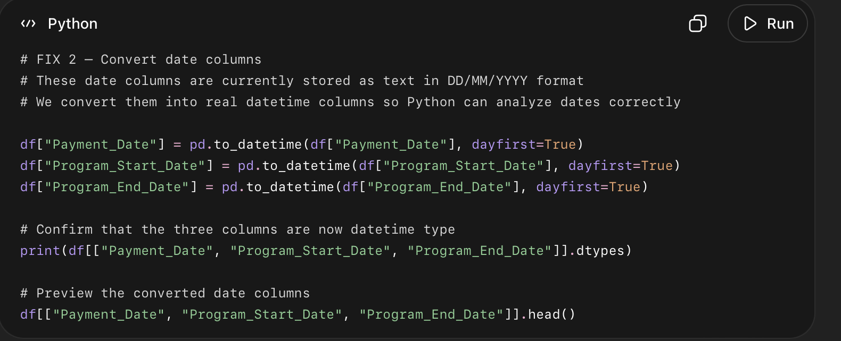

What this code did
- Took the three date columns.
- Converted them from text into real datetime format.
- Used dayfirst=True because your original date format is DD/MM/YYYY.
- Checked that the columns are now real date columns.

Code 4:
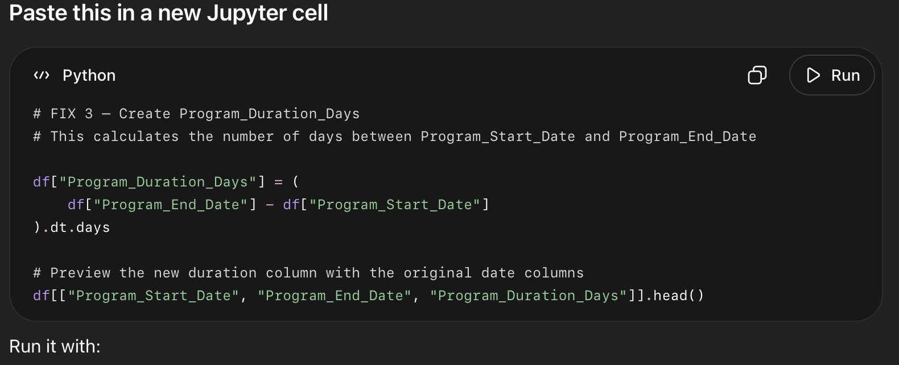

What this code did
- Took Program_End_Date.
- Subtracted Program_Start_Date.
- Converted the result into number of days.
- Created a new column called Program_Duration_Days.

Code 5:

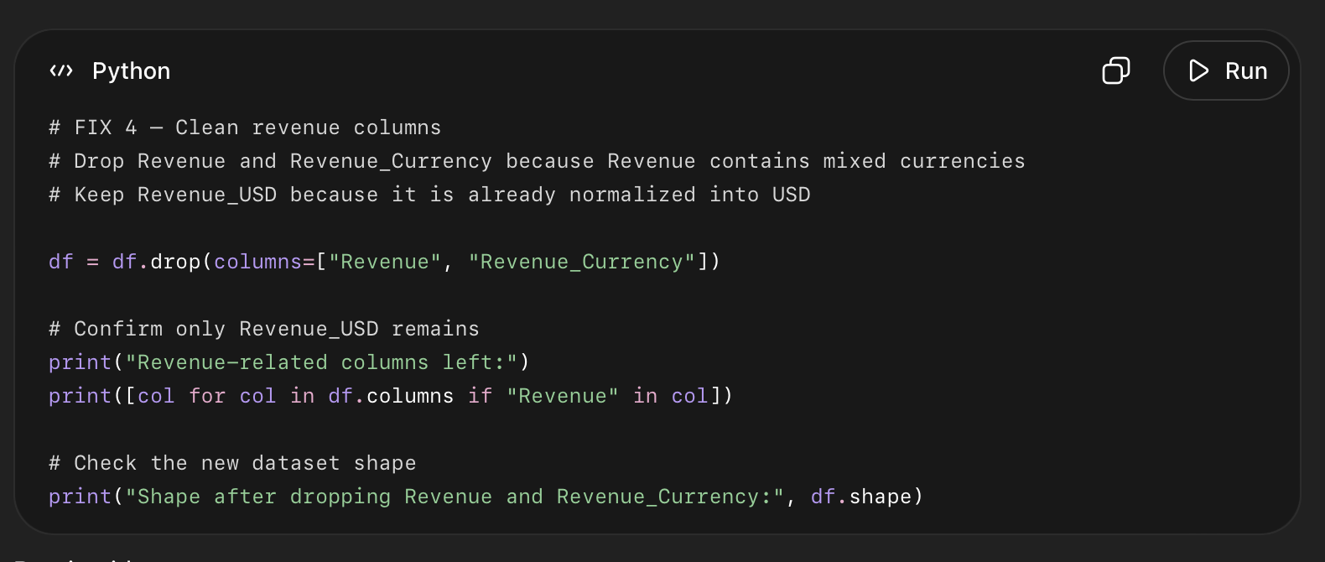

What this code did
- Removed raw revenue columns with mixed currency values.
- Kept only Revenue_USD.
- Checked that only the clean revenue column remains.
- Checked the updated dataset shape.

Code 6
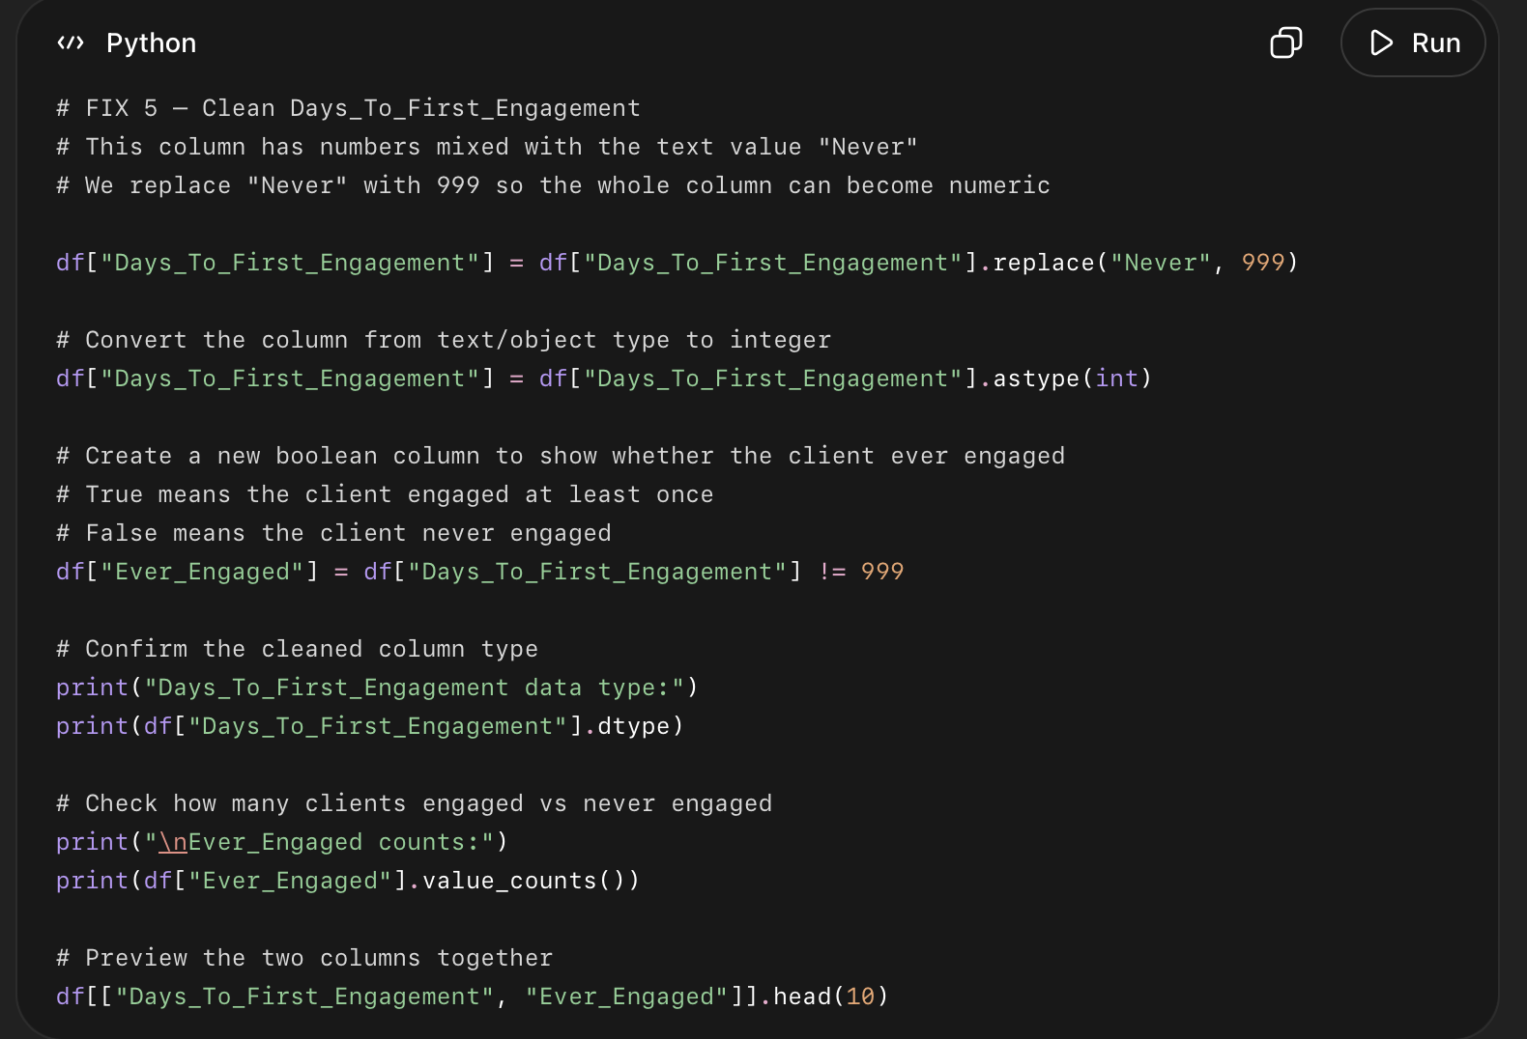

What this code did
- Replaced Never with 999.
- Converted Days_To_First_Engagement into an integer column.
- Created Ever_Engaged.
- Marked clients as:
  - True if they engaged
  - False if they never engaged

Code 7
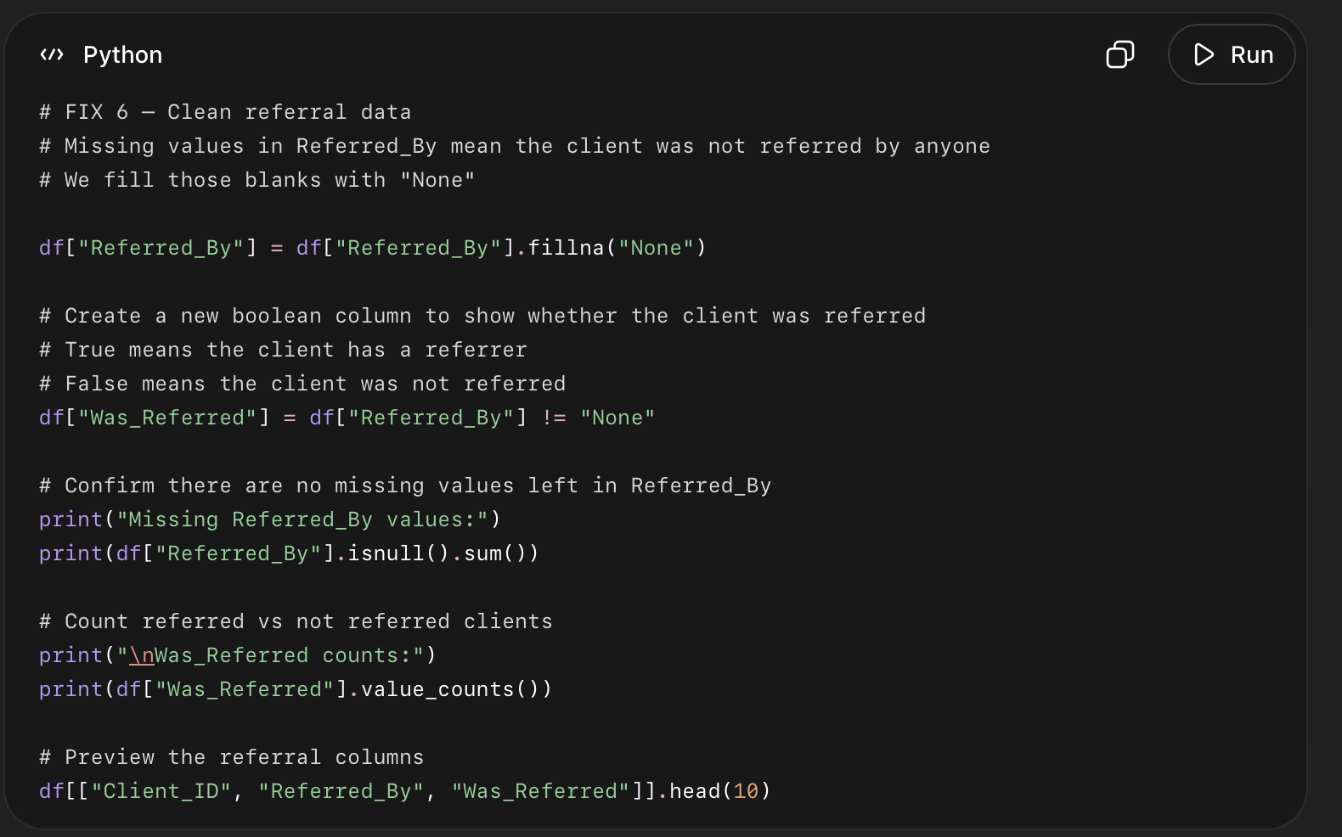

What this code did
- Filled blank Referred_By values with "None".
- Created a new column called Was_Referred.
- Marked clients as:
  - True if they had a referrer.
  - False if they did not have a referrer.
- Confirmed there are no null values left in Referred_By.
Code 8:
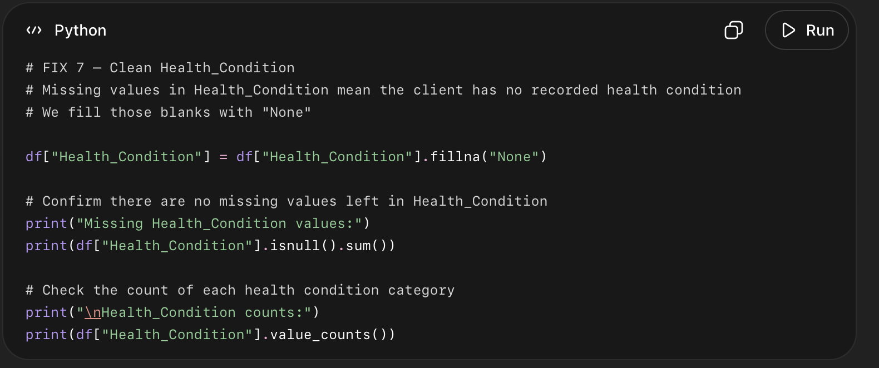

What this code did
- Replaced blank Health_Condition values with "None".
- Confirmed there are zero missing values left.
- Counted how many clients are in each health condition category.

Code 9:
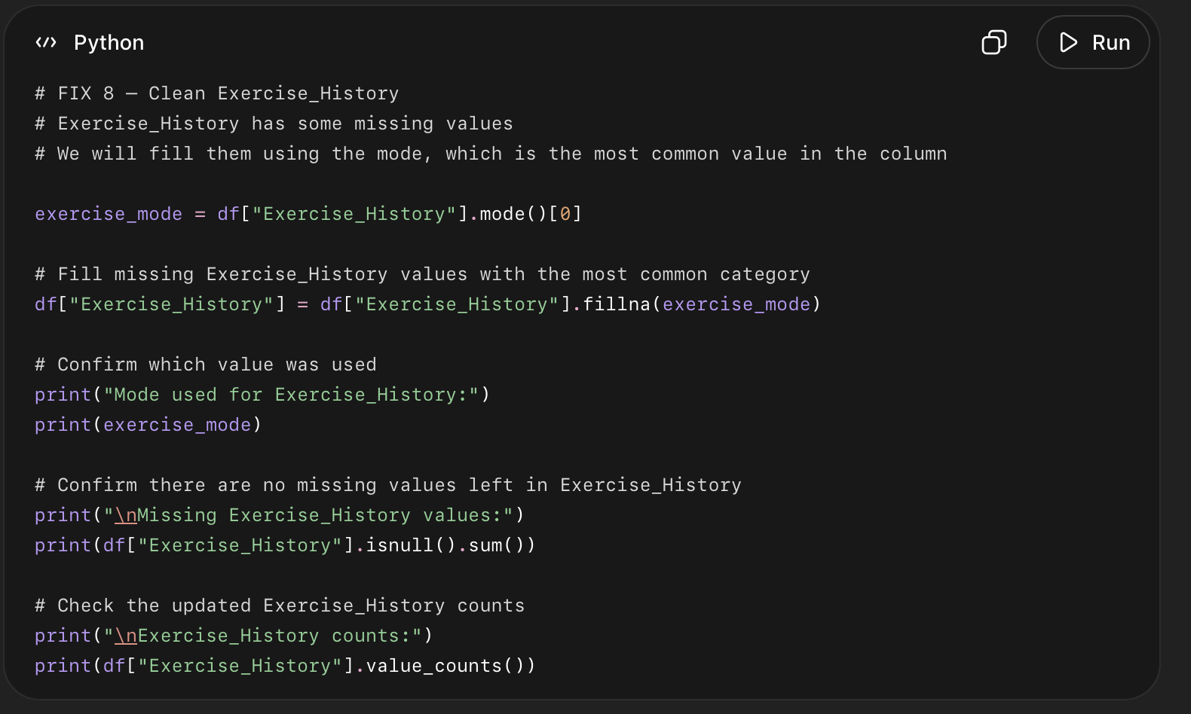

What this code did
- Found the most common value in Exercise_History.
- Stored it as exercise_mode.
- Filled missing Exercise_History values with that value.
- Confirmed there are no missing values left.
Mode means the most common value in a column. In the Exercise_History column, the values were Never, Occasional, and Regular, and Never appeared the most with 1,322 clients. Because some Exercise_History values were missing, I filled those missing values with the mode, which was Never. This helped keep all 3,000 client records instead of deleting rows, while making the column complete and ready for analysis.

Code 10
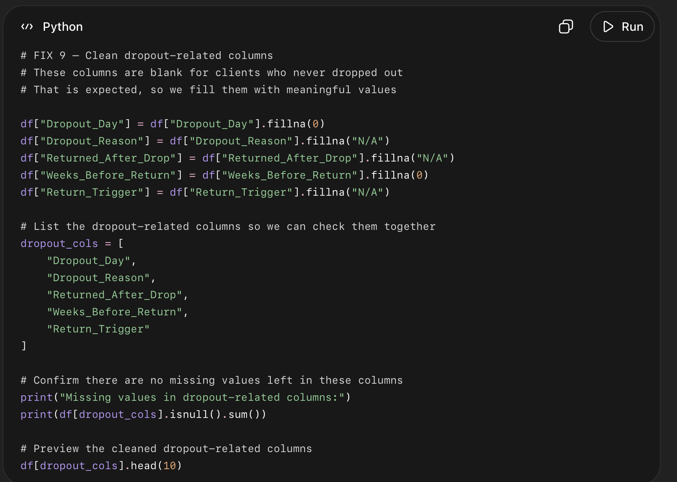

What this code did
- Filled Dropout_Day blanks with 0.
- Filled Dropout_Reason blanks with "N/A".
- Filled Returned_After_Drop blanks with "N/A".
- Filled Weeks_Before_Return blanks with 0.
- Filled Return_Trigger blanks with "N/A".
- Checked that no missing values remain in these dropout-related columns.

Code 11:
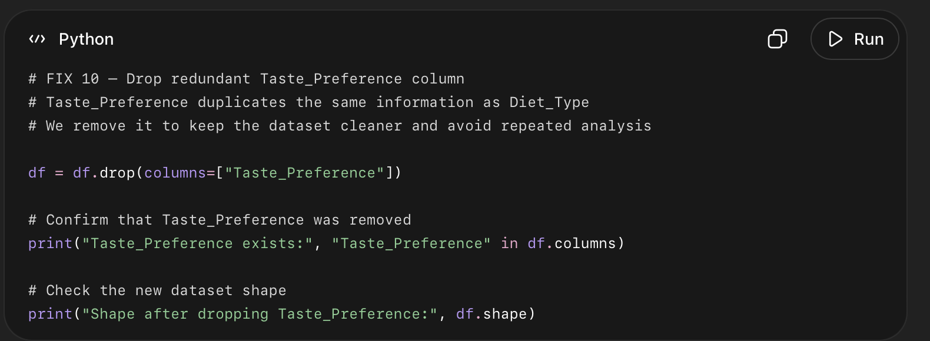

What this code did
- Removed Taste_Preference.
- Kept Diet_Type.
- Checked that Taste_Preference no longer exists.
- Checked the updated dataset shape.

Code 12:
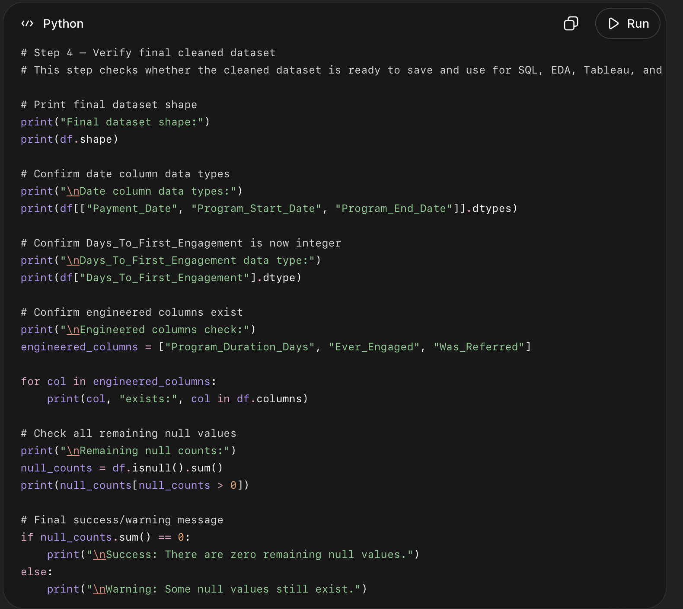
- What this code did:
Checked the final size of the cleaned dataset.
- Confirmed the dataset has:
3000 rows and 40 columns
- Checked that the three date columns are now real date columns:
Payment_Date
Program_Start_Date
Program_End_Date
- Checked that Days_To_First_Engagement is now a number column.
- Checked that the new columns we created exist:
Program_Duration_Days
Ever_Engaged
Was_Referred
- Checked if any missing/null values are still left.
- Confirmed there are zero remaining null values.
- Final meaning: the cleaned dataset is now ready to save and use for SQL, charts, Tableau, and business analysis.

Code 13
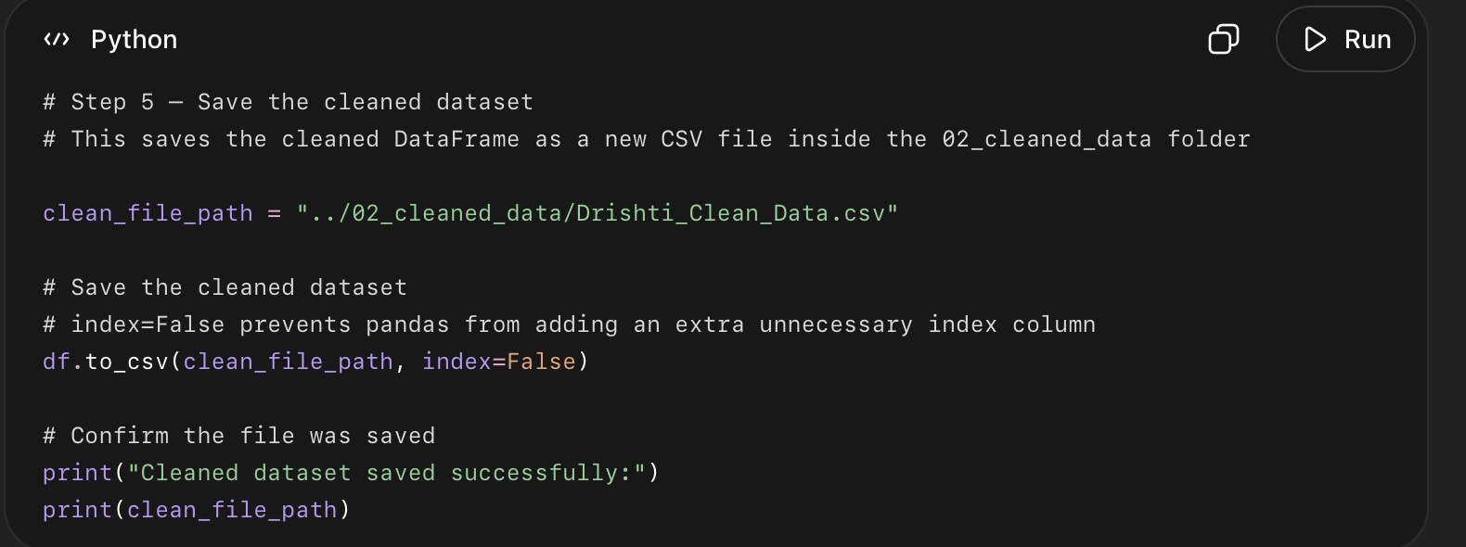

What this code did — simple points
- Chose where to save the cleaned file.
- Saved the cleaned DataFrame df as a CSV file.
- Saved it inside the 02_cleaned_data folder.
- Used index=False so Python does not create an extra unwanted column.
- Printed a success message.

